How to Change your DNS provider
(Cloudflare offers a free DNS provider. Instructions listed here and also provided for Windows 10 on this link https://developers.cloudflare.com/1.1.1.1/setup/)
YouTube link for the instruction here: https://youtu.be/kCfhq-XGVxM

Set up 1.1.1.1 – Window 10
​​ Note : Take note of any DNS addresses you might have set up, and save them in a safe place in case you need to use them later.
1) Select the Start menu > Settings.
2) On Network and Internet, select Change Adapter Options.Right-click on the Ethernet or WiFi network you are connected to and select Properties.
3) Choose Internet Protocol Version 4.
4) Select Properties > Use the following DNS server addresses.
5) Depending on what you want to configure, choose one of the following DNS addresses for IPv4:
➢ Use 1.1.1.1 resolver
1.1.1.1
1.0.0.1
➢ Block malware with 1.1.1.1 for Families
1.1.1.2
1.0.0.2
➢ Block malware and adult content with 1.1.1.1 for Families
1.1.1.3
1.0.0.3
6)Select OK.
7)Go to Internet Protocol Version 6.
8) Select Properties > Use the following DNS server addresses.
9) Depending on what you want to configure, choose one of the following DNS addresses for IPv6:
➢ Use 1.1.1.1 resolver
2606:4700:4700::1111
2606:4700:4700::1001
➢ Block malware with 1.1.1.1 for Families
2606:4700:4700::1112
2606:4700:4700::1002
➢ Block malware and adult content with 1.1.1.1 for Families
2606:4700:4700::1113
2606:4700:4700::1003

10)Select OK.

If it still doesn’t work,
Please check follow the instruction below and send me a screenshot of the result page so the team can check if it was configured correctly?
1) Please type command on your search tab on your device as below and click on “Command Prompt”

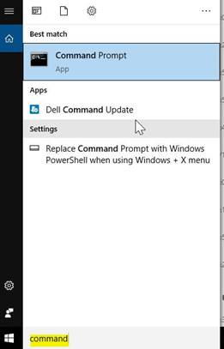

2) Copy paste this nslookup cdns3.gigya.com and hit enter as below
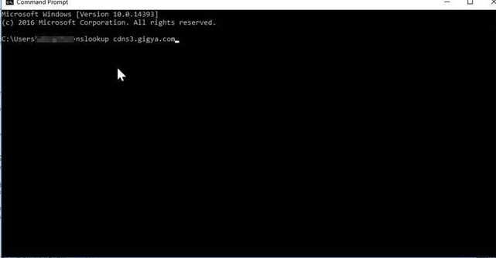

3)It should return a result like the one from our device below. We will need a screenshot from this result page to be able to check.

